

**EE 6390-Introduction to Wireless Communications Systems**

**Spring-2015**

**Final Project Report**

**Physical Layer Simulation of a Simplified LTE-OFDM System**

Tasmiah S. Khan (ID: 2021200236)

Gayathri N. Kannepalli (ID: 2021229050)

**Project Description**

This project entails simulation of simplified LTE-OFDM system in Matlab. The modulation schemes QPSK and 16-QAM are used to modulate the data. First binary data streams is generated and modulated using the two modulation schemes. Four pilots and cyclic prefix are then added. The modulated signals are transmitted over AWGN channel as well as Rayleigh fading multipath channel. The Bit Error Rate (BER) are computed under each scenario. Finally, the empirical spectral efficiency is studied for adaptive modulation scheme. A high level block diagram of the system is shown in the figure below.

**Binary bits**

**Modulate QPSK/16-QAM**

**IFFT**

**Insert Pilot**

**Insert CP**

+

000000

**Channel**

AWGN

**FFT**

**Demodulation**

**Remove CP**

The project work was equally divided between both of us. One of us worked on Adaptive modulation and BER calculation with AWGN channel and the other worked on the BER calculation with multipath channel as well as integrating all the code to make the simulation work. The contribution on the project report was equal.

**System Parameters**

The following parameters were used to simulate the system

Channel Bandwidth = 10MHz

Modulation Types: QPSK, 16-QAM

FFT Size = 64

CP Length = 16

No. of used subcarriers (Nused) = 52

No. of pilot subcarriers (Nref) = 4

No. of data subcarriers per symbol (Ndata)= 48

No. of null subcarriers (Nleft,Ndc,Nright) = 12

The following plots of BER are generated for QPSK and 16-QAM under AWGN channel

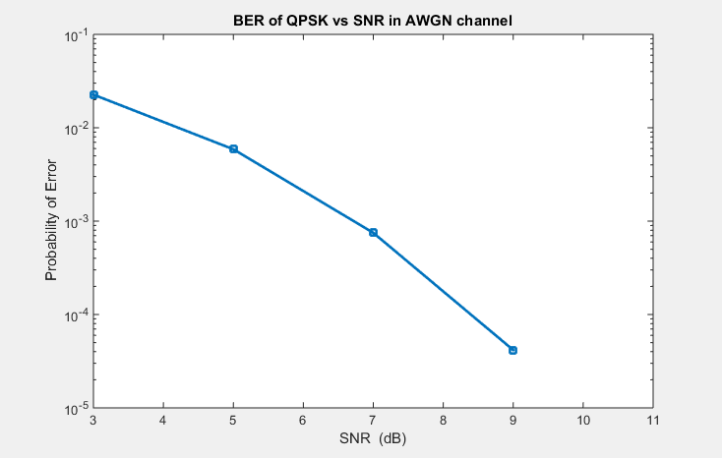

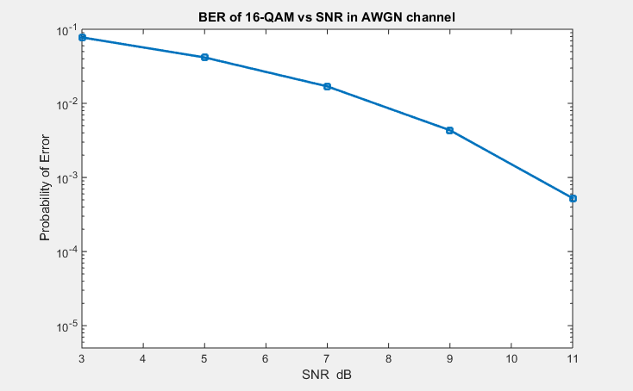

For Multipath Channel simulation, Channel B was used. BER was calculated for indoor and outdoor models for both QPSK and 16-QAM. The plots are shown below

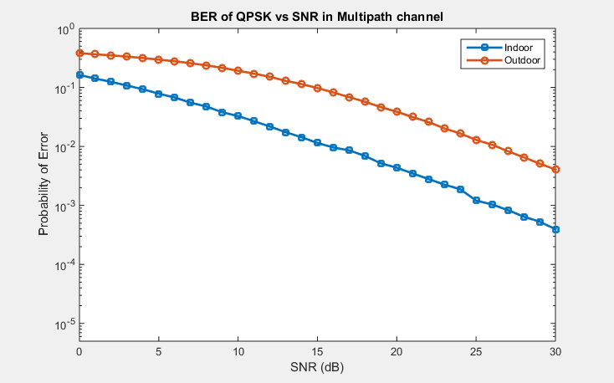

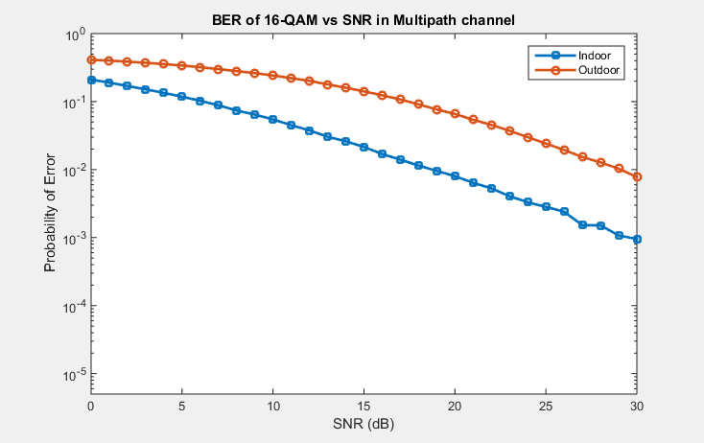

The plot of empirical spectral efficiency for the indoor and outdoor channel models using adaptive modulation is shown below

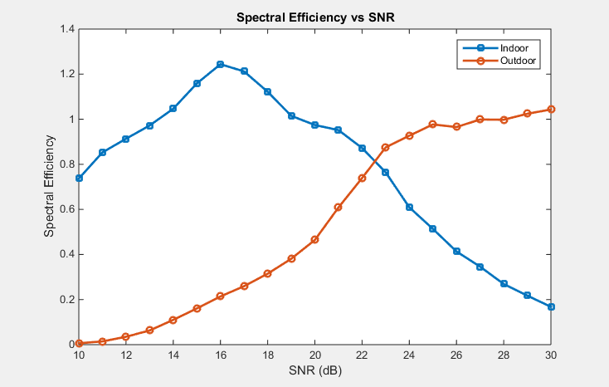

**Matlab Code**

function LTE_OFDM_SIMULATION()

clc

close all;

clear all;

sequence = rand(1,4)>0.5; %pseudo binary sequence

pilot = 2.*sequence - 1; %Pilot signal

range = 10:30; %Adaptive Modulation range

S1 = 100; %100 symbols

S2 = 10; %The number of Monte-Carlo trials for each symbol

AWGN_SNR_dB = [3 5 7 9 11];

AWGN_SNR = 10.^((AWGN_SNR_dB)./10); %SNR in linear scale

for i = 1:S1

inputQPSK = rand(1,2*48)>0.5; %input to QPSK modulator

inputQAM = rand(1,4*48)>0.5; %input to 16 QAM modulator

for j = 1:length(AWGN_SNR)

for k = 1:S2

%QPSK Modulation

QPSK_Modulated = QPSK(1,inputQPSK); %QPSK Modulation

QPSK_OFDM = Transmitter_OFDM(QPSK_Modulated,pilot); %OFDM Transmission

QPSK_OFDM_Channel = AWGN(QPSK_OFDM,AWGN_SNR(j)); %AWGN Channel

[QPSKDemodulated_OFDM var] = Receiver_OFDM(1,QPSK_OFDM_Channel,[],[],[]); %OFDM Receiver

QPSK_Demodulated = QPSK(2,QPSKDemodulated_OFDM); %QPSK Demodulation

error1(k) = sum(inputQPSK ~= QPSK_Demodulated)/(48*2); %bit error probability

%16 QAM Modulation

QAM_Modulated = QAM(1,inputQAM); %QAM Modulation

QAM_OFDM = Transmitter_OFDM(QAM_Modulated,pilot); %OFDM Transmission

QAM_OFDM_Channel = AWGN(QAM_OFDM,AWGN_SNR(j)); %AWGN Channel

[QAMDemodulated_OFDM var] = Receiver_OFDM(1,QAM_OFDM_Channel,[],[],[]); %OFDM Receiver

QAM_Demodulated = QAM(2,QAMDemodulated_OFDM); %QAM Demodulation

error2(k) = sum(inputQAM ~= QAM_Demodulated)/(48*4); %bit error probability

end

sym_error1(i,j) = sum(error1)/S2;

sym_error2(i,j) = sum(error2)/S2;

end

end

for j = 1:length(AWGN_SNR)

bit_error1(j) = sum(sym_error1(:,j))/S1;

ber_error2(j) = sum(sym_error2(:,j))/S1;

end

figure

semilogy(AWGN_SNR_dB,bit_error1);

title('BER of QPSK vs SNR in AWGN channel');

xlabel('SNR (dB)');

ylabel('Probability of Error');

figure

semilogy(AWGN_SNR_dB,ber_error2);

title('BER of 16-QAM vs SNR in AWGN channel');

xlabel('SNR dB');

ylabel('Probability of Error');

AWGN_SNR_dB = 0:30;

AWGN_SNR = 10.^((AWGN_SNR_dB)./10); %SNR in linear scale

for i = 1:S1

inputQPSK = rand(1,2*48)>0.5; %input to QPSK modulator

inputQAM = rand(1,4*48)>0.5; %input to 16 QAM modulator

[tapsIndoor tapsOutdoor] = Multipath_Taps();

for j = 1:length(AWGN_SNR)

for k = 1:S2

%QPSK Modulation

QPSK_Modulated = QPSK(1,inputQPSK); %QPSK Modulation

QPSK_OFDM = Transmitter_OFDM(QPSK_Modulated,pilot); %OFDM Transmission

[QPSK_Indoor_OFDM_Channel QPSK_Outdoor_OFDM_Channel] = Channel_multipath(QPSK_OFDM, AWGN_SNR(j), tapsIndoor, tapsOutdoor); %Multipath Channel

[QPSKDemodulated_Indoor_OFDM QPSKDemodulated_Outdoor_OFDM] = Receiver_OFDM(2,QPSK_Indoor_OFDM_Channel,QPSK_Outdoor_OFDM_Channel,tapsIndoor,tapsOutdoor); %OFDM Receiver

QPSKDemodulated_Indoor = QPSK(2,QPSKDemodulated_Indoor_OFDM); %QPSK Demodulation for Indoor

QPSKDemodulated_Outdoor = QPSK(2,QPSKDemodulated_Outdoor_OFDM); %QPSK Demodulation for Outdoor

error_Indoor1(k) = sum(inputQPSK ~= QPSKDemodulated_Indoor)/(48*2); %BER for Indoor

error_Outdoor1(k) = sum(inputQPSK ~= QPSKDemodulated_Outdoor)/(48*2); %BER for Outdoor

%16 QAM Modulation

QAM_Modulated = QAM(1,inputQAM); %QAM Modulation

QAM_OFDM = Transmitter_OFDM(QAM_Modulated,pilot); %OFDM Transmission

[QAM_Indoor_OFDM_Channel QAM_Outdoor_OFDM_Channel] = Channel_multipath(QAM_OFDM, AWGN_SNR(j), tapsIndoor, tapsOutdoor); %Multipath Channel

[QAMDemodulated_Indoor_OFDM QAM_Demod_OFDMP] = Receiver_OFDM(2,QAM_Indoor_OFDM_Channel,QAM_Outdoor_OFDM_Channel,tapsIndoor,tapsOutdoor); %OFDM Receiver

QAMDemodulated_Indoor = QAM(2,QAMDemodulated_Indoor_OFDM); %QAM Demodulation for Indoor

QAMDemodulated_Outdoor = QAM(2,QAM_Demod_OFDMP); %QAM Demodulation for Outdoor

error_Indoor2(k) = sum(inputQAM ~= QAMDemodulated_Indoor)/(48*4); %BER for Indoor

error_Outdoor2(k) = sum(inputQAM ~= QAMDemodulated_Outdoor)/(48*4); %BER for Outdoor

end

per_Indoor1(i,j) = sum(error_Indoor1)/S2;

per_Outdoor1(i,j) = sum(error_Outdoor1)/S2;

per_Indoor2(i,j) = sum(error_Indoor2)/S2;

per_Outdoor2(i,j) = sum(error_Outdoor2)/S2;

end

end

for j = 1:length(AWGN_SNR) %Total Probability

ber_Indoor1(j) = sum(per_Indoor1(:,j))/S1;

ber_Outdoor1(j) = sum(per_Outdoor1(:,j))/S1;

ber_Indoor2(j) = sum(per_Indoor2(:,j))/S1;

ber_Outdoor2(j) = sum(per_Outdoor2(:,j))/S1;

end

%QPSK

figure

semilogy(AWGN_SNR_dB,ber_Indoor1);

hold on;

semilogy(AWGN_SNR_dB,ber_Outdoor1);

legend('Indoor','Outdoor',1);

title('BER of QPSK vs SNR in Multipath channel');

xlabel('SNR (dB)');

ylabel('Probability of Error');

%16 QAM

figure

semilogy(AWGN_SNR_dB,ber_Indoor2);

hold on;

semilogy(AWGN_SNR_dB,ber_Outdoor2);

legend('Indoor','Outdoor',1);

title('BER of 16-QAM vs SNR in Multipath channel');

xlabel('SNR (dB)');

ylabel('Probability of Error');

%Adaptive Modulation

Indoor_SpectralEff = zeros(1,length(range));

Outdoor_SpectralEff = zeros(1,length(range));

for k = 1:S1

[tapsIndoor tapsOutdoor] = Multipath_Taps();

[spectralEff_Indoor spectralEff_Outdoor] = adaptive_Modulation(tapsIndoor,tapsOutdoor);

Indoor_SpectralEff = Indoor_SpectralEff + spectralEff_Indoor;

Outdoor_SpectralEff = Outdoor_SpectralEff + spectralEff_Outdoor;

end

Indoor_SpectralEff = Indoor_SpectralEff./S1;

Outdoor_SpectralEff = Outdoor_SpectralEff./S1;

figure

plot(range,Indoor_SpectralEff);

hold on;

plot(range,Outdoor_SpectralEff);

legend('Indoor','Outdoor',2);

title('Spectral Efficiency vs SNR');

xlabel('SNR (dB)');

ylabel('Spectral Efficiency');

end

% Functions:

% QPSK Modulation:

function [output] = QPSK(value, input)

QPSK_signals = [-1-1i -1+1i 1+1i 1-1i]; %corresponding to [-3pi/4 3pi/4 pi/4, -pi/4]

if (value == 1)

QPSK_bits = 2.*input - 1; %mapping the bits to +1 or -1

seperation = reshape(QPSK_bits,2,length(input)/2); %QPSK in-phase/quadrature-phase seperation

QPSK_inphase = seperation(1,:); %in-phase component (input) for QPSK

QPSK_quadrature = seperation(2,:); %quadrature-phase component (input) for QPSK

output = QPSK_inphase + (1i.*QPSK_quadrature);

else

output = zeros(1,length(input)*2);

QPSK_distance = [abs(input - QPSK_signals(1));

abs(input - QPSK_signals(2));

abs(input - QPSK_signals(3));

abs(input - QPSK_signals(4))];

for m = 1:length(input)

QPSK_symbol = QPSK_signals(find(QPSK_distance(:,m)==min(QPSK_distance(:,m)),1,'first'));

output(2*m - 1) = (real(QPSK_symbol)+1)/2;

output(2*m) = (imag(QPSK_symbol)+1)/2;

end

end

end

%16-QAM Modulation:

function [output] = QAM(value, input)

QAM_symbols = (2/sqrt(10)).*[-3 -1 3 1]; %corresponding to [00 01 10 11] and making Eb = 1

if (value == 1)

QAM_seperation = reshape(input,4,length(input)/4); %QAM in-phase/quadrature-phase bits seperation

d1 = QAM_seperation(1,:); %d1 of QAM

d2 = QAM_seperation(2,:); %d2 of QAM

d3 = QAM_seperation(3,:); %d3 of QAM

d4 = QAM_seperation(4,:); %d4 of QAM

QAM_inphase = zeros(1,length(input)/4);

QAM_seperation = zeros(1,length(input)/4);

for i = 1:length(input)/4

QAM_inphase(i) = QAM_symbols(((2*d1(i))+d2(i))+ 1);

QAM_seperation(i) = QAM_symbols(((2*d3(i))+d4(i))+ 1);

end

output = QAM_inphase + (1i.*QAM_seperation);

else

output = zeros(1,length(input)*4);

QAM_distance = zeros(length(QAM_symbols)*4,length(input));

for i = 1:(length(QAM_symbols)*4)

bin = dec2bin(i-1,4);

QAM_distance(i,:) = abs(input - ((QAM_symbols(bin2dec(bin(1:2))+ 1))+(1i*(QAM_symbols(bin2dec(bin(3:4))+ 1)))));

end

for i = 1:length(input)

bin = dec2bin((find(QAM_distance(:,i)==min(QAM_distance(:,i)),1,'first')-1),4);

output(4*i - 3) = str2double(bin(1));

output(4*i - 2) = str2double(bin(2));

output(4*i - 1) = str2double(bin(3));

output(4*i) = str2double(bin(4));

end

end

end

% AWGN Channel:

function [signal_received] = AWGN(input, awgnSNR)

inputLength = length(input); %Input length

signal_inphase = real(input) + (1/sqrt(2*awgnSNR))*randn(1,inputLength); % In-phase received signal

signal_quadrature = imag(input) + (1/sqrt(2*awgnSNR))*randn(1,inputLength);% Quadrature received signal

signal_received = signal_inphase + (1i.*signal_quadrature);

end

%Multipath Channel Taps:

function [tapsIndoor tapsOutdoor] = Multipath_Taps()

sampleDuration = 1/(10*10^6); %Channel bandwidth = 10MHz

delayIndoor = (10^-9).*[0 100 200 300 500 700]; %Delay profile for Indoor channel model

relativePower_IndoordB = [0 -3.6 -7.2 -10.8 -18 -25.2]; %Power profile for indoor channel model

delayOutdoor = (10^-9).*[0 5 30 45 75 90 105 140 210 230 250 270 275 475 595 690]; %Delay profile for Outdoor Multipath channel model

relativePower_OutdoordB = [-1.5 -10.2 -16.6 -19.2 -20.9 -20.6 -16.6 -16.6 -23.9 -12 -23.9 -21 -17.7 -24.6 -22 -29.2]; %Power profile for Outdoor Multipath channel model

tapsIndoor = zeros(1,80);

tapsOutdoor = zeros(1,80);

relativePower_Indoor = 10.^(relativePower_IndoordB./10);

relativePower_Outdoor = 10.^(relativePower_OutdoordB./10);

for i = 1:length(delayIndoor)

tapsIndoor(round(delayIndoor(i)/sampleDuration) + 1) = sqrt(relativePower_Indoor(i)*((randn(1,1)^2) + (randn(1,1)^2))/2);

end

for m = 1:length(delayOutdoor)

tapsOutdoor(round(delayOutdoor(m)/sampleDuration) + 1) = sqrt(relativePower_Outdoor(m)*((randn(1,1)^2) + (randn(1,1)^2))/2);

end

end

% Multipath Channels:

function [indoorChan outdoorChan] = Channel_multipath(input, awgnSNR, tapsIndoor, tapsOutdoor)

inputLength = length(input); %Input length

noise_inphase = (1/sqrt(2*awgnSNR))*randn(1,inputLength); %In-phase noise

noise_quadrature = (1/sqrt(2*awgnSNR))*randn(1,inputLength); %Quadrature-phase noise

indoorChan = ifft((fft(input,inputLength).*fft(tapsIndoor,inputLength)),inputLength) + (noise_inphase + (1i*noise_quadrature));

outdoorChan = ifft((fft(input,inputLength).*fft(tapsOutdoor,inputLength)),inputLength) + (noise_inphase + (1i*noise_quadrature));

end

% OFDM Transmit:

function [output] = Transmitter_OFDM(input, pilot)

fft_size = 64; %Length of fft/ifft

Length_cp = 16; %Length of cyclic prefix

Begin_cp = fft_size - Length_cp + 1;

End_cp = fft_size;

ofdmSequence = [zeros(1,6) input(1:5) pilot(1) input(6:18) pilot(2) input(19:24) zeros(1,1) input(25:30) pilot(3) input(31:43) pilot(4) input(44:48) zeros(1,5)];

inputIFFT = sqrt(fft_size)*ifft(ofdmSequence,64); %IFFT

output = [inputIFFT(Begin_cp:End_cp) inputIFFT]; %Adding Cyclic Prefix

end

% OFDM Receive:

function [IndoorDetection OutdoorDetection] = Receiver_OFDM(value,indoor, outdoor, IndoorTaps, OutdoorTaps)

fft_size = 64; %Length of fft/ifft

outputLength = length(indoor); %Length of received signal (same for both Indoor and Outdoor)

if (value == 1) %value = 1 for AWGN channel

Indoorfft = (1/sqrt(fft_size))*fft(indoor(17:80),fft_size);

IndoorDetection = [Indoorfft(7:11) Indoorfft(13:25) Indoorfft(27:32) Indoorfft(34:39) Indoorfft(41:53) Indoorfft(55:59)];

OutdoorDetection = [];

else

indoor = ifft((fft(indoor,outputLength)./fft(IndoorTaps,outputLength)),outputLength);

outdoor = ifft((fft(outdoor,outputLength)./fft(OutdoorTaps,outputLength)),outputLength);

Indoorfft = (1/sqrt(fft_size))*fft(indoor(17:80),fft_size);

Outdoorfft = (1/sqrt(fft_size))*fft(outdoor(17:80),fft_size);

IndoorDetection = [Indoorfft(7:11) Indoorfft(13:25) Indoorfft(27:32) Indoorfft(34:39) Indoorfft(41:53) Indoorfft(55:59)];

OutdoorDetection = [Outdoorfft(7:11) Outdoorfft(13:25) Outdoorfft(27:32) Outdoorfft(34:39) Outdoorfft(41:53) Outdoorfft(55:59)];

end

end

% Adaptive modulation:

function [spectralEffIndoor spectralEffOutdoor] = adaptive_Modulation(tapsIndoor,tapsOutdoor)

lengh = 64;

SNRrange = 10:30; %range of average SNR is from 10 to 30dB

noisePower = 1./(10.^((SNRrange)./10));

fftIndoor = fft(tapsIndoor,lengh);

fftOutdoor = fft(tapsOutdoor,lengh);

spectralEffOutdoor = zeros(1,length(SNRrange));

spectralEffIndoor = zeros(1,length(SNRrange));

for i = 1:length(SNRrange)

SNRIndoor = 10*log10((abs(fftIndoor).^2)./noisePower(i));

SNROutdoor = 10*log10((abs(fftOutdoor).^2)./noisePower(i));

nbits = 0;

for j = 1:length(SNRIndoor)

if ((SNRIndoor(j) >= 10.61) && (SNRIndoor(j) < 13.94)) %QPSK

nbits = nbits + 2;

else if ((SNRIndoor(j) >= 17.25) && (SNRIndoor(j) < 20.4)) %16 QAM

nbits = nbits + 4;

end

end

end

spectralEffIndoor(i) = nbits/length(SNRIndoor);

nbits = 0;

for j = 1:length(SNROutdoor)

if ((SNROutdoor(j) >= 10.61) && (SNROutdoor(j) < 13.94)) %QPSK

nbits = nbits + 2;

else if ((SNROutdoor(j) >= 17.25) && (SNROutdoor(j) < 20.4)) %16 QAM

nbits = nbits + 4;

end

end

end

spectralEffOutdoor(i) = nbits/length(SNROutdoor);

end

end